MWCL T10 Format 2023
Since we have 9(odd number) teams and to give equal chance to all teams playing in the 2nd week of the T10 we decided the below format.
Round 1:
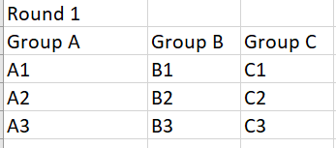
Each team is going to play 2 games each at end of Round 1.
Round 2:
To make it more competitive and also keep the bottom teams at the end of round 1 involved and compete for play off spot we decided to have Rank 1 teams of each group pay each other from other groups and ran2 2 teams from each group play Rank 2 from other groups and Rank 3 play other Rank 3 teams from other groups
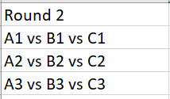
By end of Round 2 each team would have played 4 games.
Round 3:
The top 6 teams after 4 games played will be moving to Round 3. Top 2 will qualify to semis directly and Ranks 3,4,5,6 play to qualify for the semis.
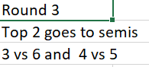
Semis:
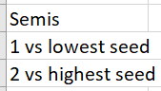
Finals:
Winner of semis.

Basic rules:
- Powerplay will be for the first 3 overs of the innings. 9 players inside the circle
- Round 1 teams can decide and agree to play from 1 end all game or 5 overs 1 end followed by 5 overs other end
- No bowler can bowl more than 2 overs
- Incase of washout. The points will be split. If weather interrupts in the middle of the game, batting 2nd team should have played at least 5 overs and a score comparison will determine the winner. In case of scores tie, team losing less wickets are declared the winner. If still there is no winner, then its determined a tie.
- NO SUPER OVER for league games. Super over only from Round 3 and forward

